Experiment No:
Date:

Experiment Title: Testing of Requirement

Aim
The aim of this experiment is to study and develop a system by analyzing the given problem and implementing an appropriate solution using structured techniques. The experiment focuses on understanding how data flows within a system, identifying the required operations, and designing a model that represents the working of the system clearly. It also helps in gaining practical knowledge about system design and analysis.

Conditions
The system is developed under certain conditions and constraints to ensure proper functionality and efficiency. These conditions include handling valid input data, maintaining correct flow of operations, and producing accurate output. The system should operate within the given limits of time and resources, and it must avoid unnecessary complexity. Additionally, it should handle different cases properly without causing errors or unexpected results. Considering these conditions ensures that the system remains reliable and efficient.

Description
The description of the system provides a clear understanding of the problem and its requirements. The system is designed to take input data, process it according to the defined logic, and generate the required output. It involves different components such as input handling, processing units, and output generation. Each component plays an important role in the overall functioning of the system. The description also explains how the system interacts with users and how data is managed throughout the process.

Methodology
The methodology refers to the step-by-step approach followed to solve the problem. Initially, the problem is analyzed to understand the requirements clearly. Then, a suitable design is prepared using diagrams or logical steps. After designing, the implementation is carried out using appropriate programming techniques. Finally, the system is tested to verify whether it produces correct results. This systematic approach ensures that the solution is well-organized and easy to understand.
Exercise 1
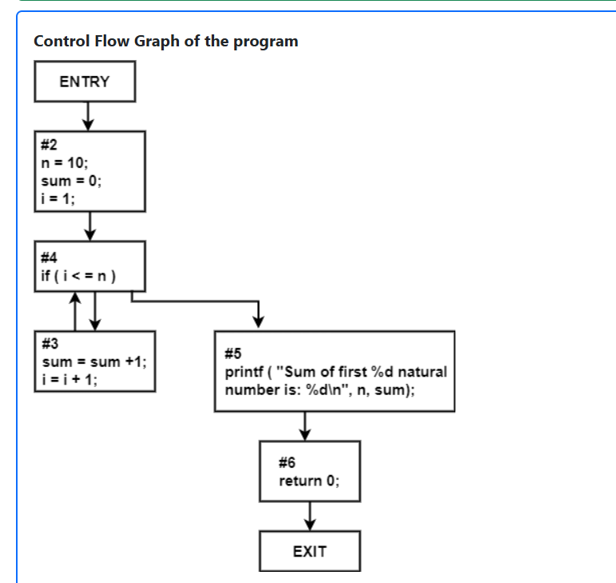

Output:
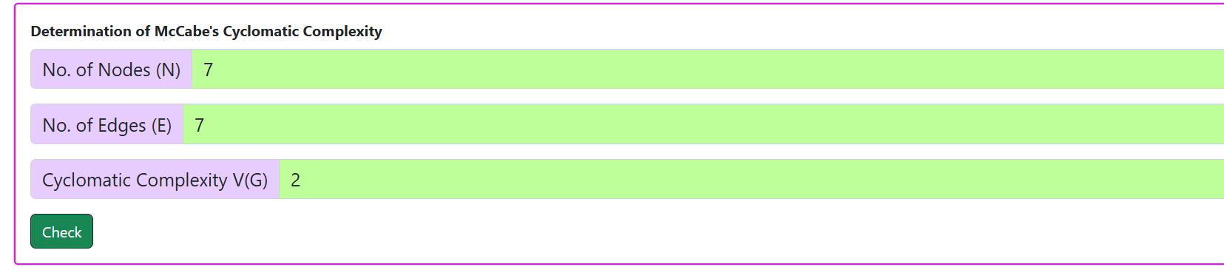

Exercise 2

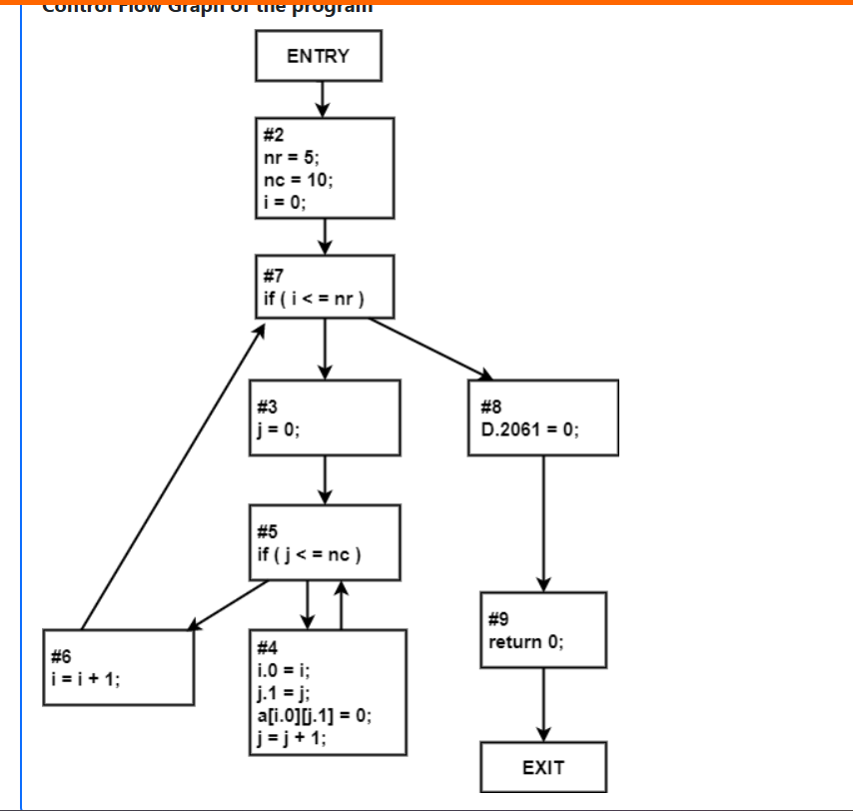

Output:
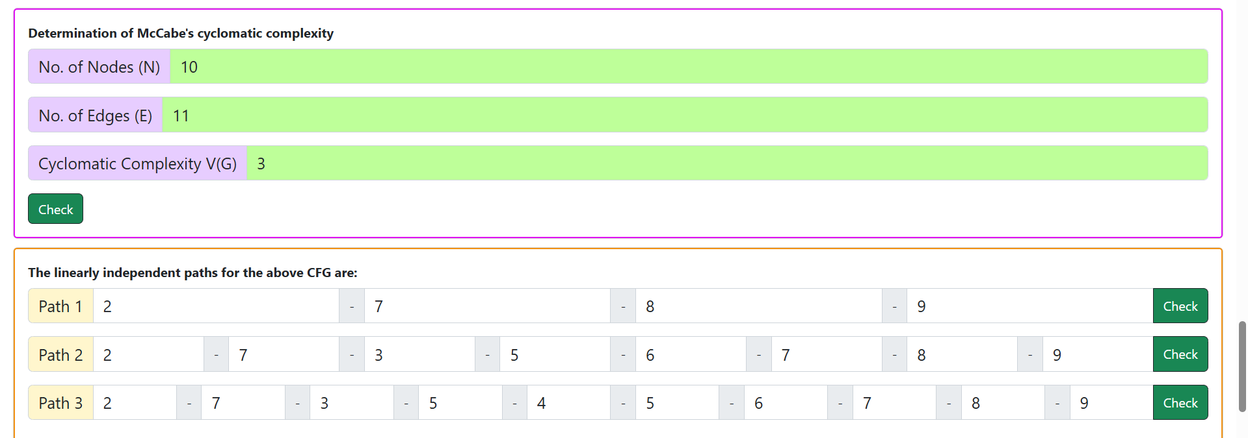

Exercise 3
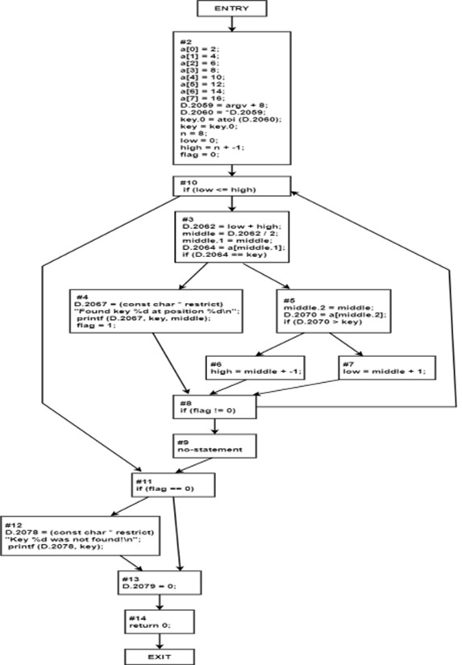

Output:
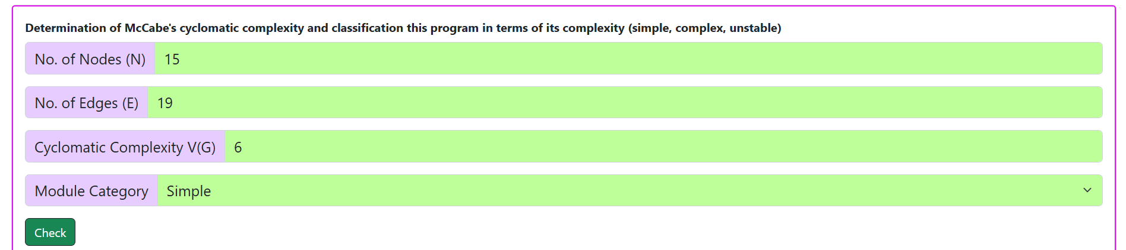

Working
The working of the system is based on a sequence of operations where input data is processed to produce output. First, the system accepts input either from the user or predefined values. Then, it applies logical operations such as conditions, loops, or algorithms to process the data. After processing, the final output is generated and displayed. Each step in the working process is interconnected, ensuring smooth flow of data within the system. Proper working of the system depends on correct implementation and logical accuracy.

Result
The result of the experiment shows that the system is able to perform the required operations successfully. The input data is processed correctly, and the expected output is obtained. The system functions efficiently under the given conditions and produces reliable results. This confirms that the design and implementation of the system are accurate and effective.

Conclusion
From this experiment, it is concluded that proper analysis, planning, and implementation are essential for developing a successful system. The experiment helps in understanding how a problem can be converted into a structured solution. It also highlights the importance of designing systems that are efficient, reliable, and easy to use. The knowledge gained from this experiment can be applied to solve real-world problems effectively.

